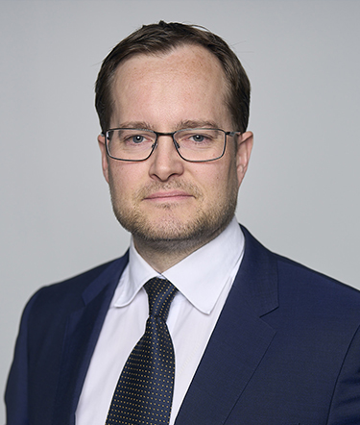

Alf Stian Mauritz
Group CSO - President North and
Central Europe at IEC Telecom Group

Alf Stian Mauritz is the Chief Strategy Officer (CSO) and President of North & Central Europe at IEC Telecom Group. He is instrumental in strengthening partnerships and steering new business development within the rapidly evolving satellite communications industry.

Alf Stian has 20+ years of experience in providing advanced communication solutions to the government and maritime sectors. He established IEC Telecom Norway in 2005 and led the expansion into Sweden in 2013. He has steered the business development initiatives at IEC Telecom towards mobile communications and ensured a robust focus on sales management to create sustained growth and rewarding strategic alliances in the European market.

Alf Stian graduated from Nanyang Business School in 2003 and his strategic leadership at IEC Telecom Group has helped the brand become known for reliable and innovative communication solutions.

