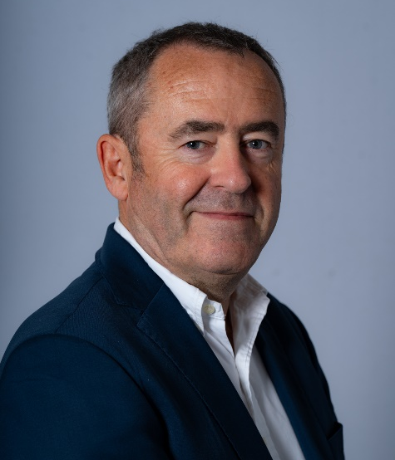

Gwenaël Lohéac
Partner & Group CPO
President Europe & West Africa
IEC Telecom Europe

Gwenaël Lohéac is the CEO of IEC Telecom Europe and Partner & Chief Procurement Officer of IEC Telecom Group, driving the company’s strategic growth across Europe, Africa, and international markets. He ensures operational excellence, fosters innovation, and builds strong global supplier partnerships, contributing to the group’s competitiveness and international reach.

Having joined IEC Telecom Group in 1997, Gwenaël, one of the founders of the company, has played a key role in shaping its regional and global presence. As CEO of IEC Telecom Europe, he led the company’s expansion in enterprise, maritime, governmental, and humanitarian satellite communications. Under his leadership, IEC Telecom has become a leading independent European player, recognized for the reliability and innovation of its communication solutions.

An entrepreneur and hands-on manager, Gwenaël combines strategic vision with execution capability. He excels at identifying new growth opportunities, mobilizing talent, and strengthening key partnerships. Based in Cergy, France, he holds a Master’s in International Business and brings nearly three decades of experience in satellite communications and international business development, guiding the group’s mission to deliver reliable, cutting-edge communication solutions worldwide.

