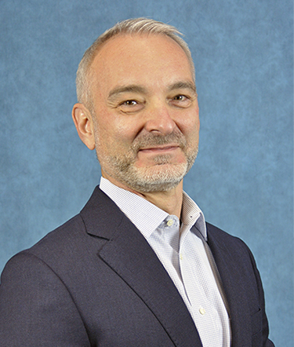


Steve Noel
Vice President of the Satcom Solutions
Thales Defense & Security, Inc. (TDSI)

Steve Noel is the Vice President of the Satcom Solutions business unit for Thales Defense & Security, Inc. (TDSI). He leads the sales distribution, business strategy, and portfolio expansion for the ThalesLINK family of products within the global commercial and defense satellite communications markets.
Mr. Noel joined TDSI in 2009 as a Principal Engineer and quickly escalated to managing engineer roles where he was able to develop cutting-edge satcom solutions. Leading up to his current role, he was Product Line Director for Satcom Solution, where he developed and launched the ThalesLINK family of products that have quickly become the preferred L-band solutions in markets worldwide. Prior to joining TDSI, Mr. Noel worked for Nortel Networks and Raytheon also in leading engineer roles.
Mr. Noel graduated from West Virginia University in 1994 with a Master’s degree in Electrical Engineering.

